**Overview**

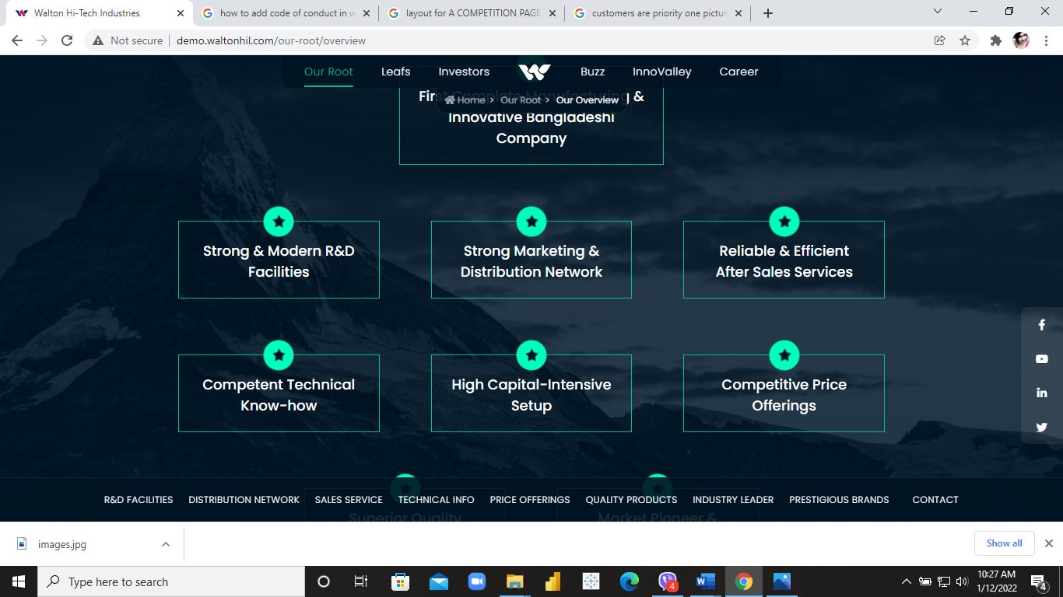

**Boxes**

1. First Complete Manufacturing & Innovative Bangladeshi Company- **First Complete Bangladeshi Manufacturing Company**
2. Strong & Modern R&D Facilities- **Future-Ready R&I Facilities**
3. Strong Marketing & Distribution Network- **Robust Marketing & Distribution Network**
4. Reliable & Efficient After Sales Services
5. Competent Technical Know-how
6. High Capital-Intensive Setup
7. Competitive Price Offerings
8. Superior Quality Products
9. Market Pioneer & Leader in the Industry- **Leaders in the E&E Industry**
10. Brand – WALTON & MARCEL are the most trusted & prestigious Brands – **Brand of Choice & Trust**

**Recognition**

1. **LOCAL AWARDS**
2. **INTERNATIONAL AWARDS**
3. **CERTIFICATIONS**

**Two Tiles under Certifications:**

* 1. **Products**
  2. **Compliance & Industry**

**(ONLY IMAGES WILL BE SHOWN)**

**LEAFS**

**WALTON**

Wind of Alteration- FONT- SOGOE PRINT

Walton Group is the parent company to leading Bangladeshi E&E companies including WHIL, WDIL, Marcel, Safe, DPI exporting to more than 40 countries, proudly flaunting “Made in Bangladesh” tag on all of their products.

**MARCEL**

Marvel of Excellence

A sister concern of Walton Hi-Tech Industries PLC and operated under the umbrella of Walton Group, Marcel has been designing, manufacturing, exporting, and retailing consumer electronics, home appliances, and automobiles since its establishment in 2006.

**SAFE**

Sustainable Appliances for Everyone

The latest addition to the Walton Family, Safe launched its business on the 4th of February, 2020 through manufacturing and delivering highest quality electrical appliances such as LED lights, extension sockets or multi-plugs, circuit breaker, ceiling fans etc. by maintaining International Electrotechnical Commission (IEC) Standards.

**CSR**

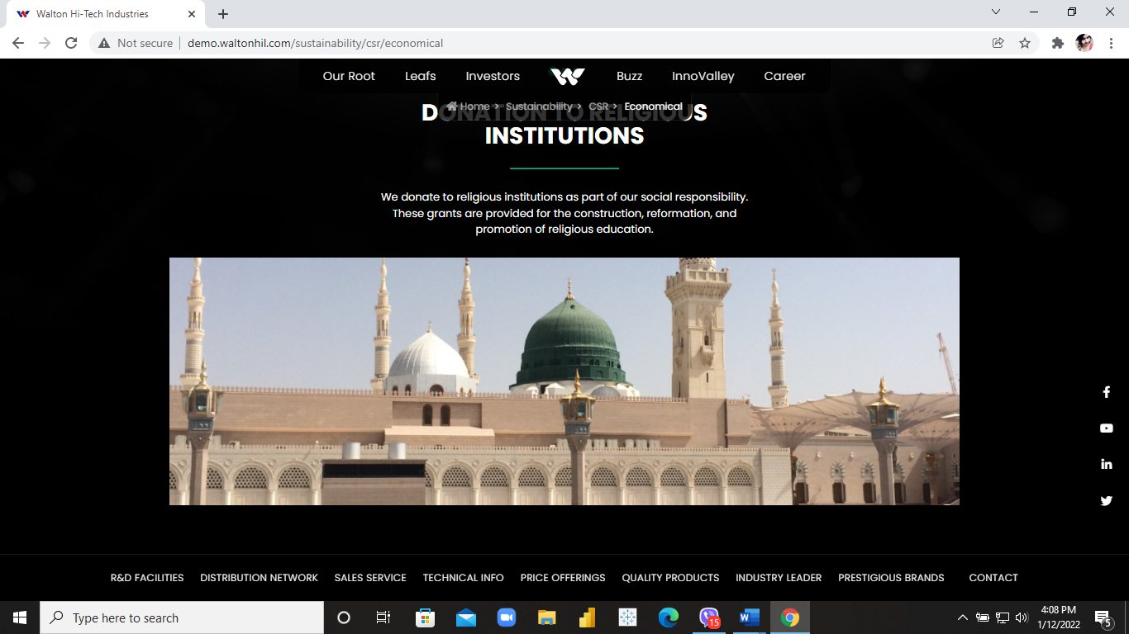

**Add sliders here to accommodate 4 pictures.**

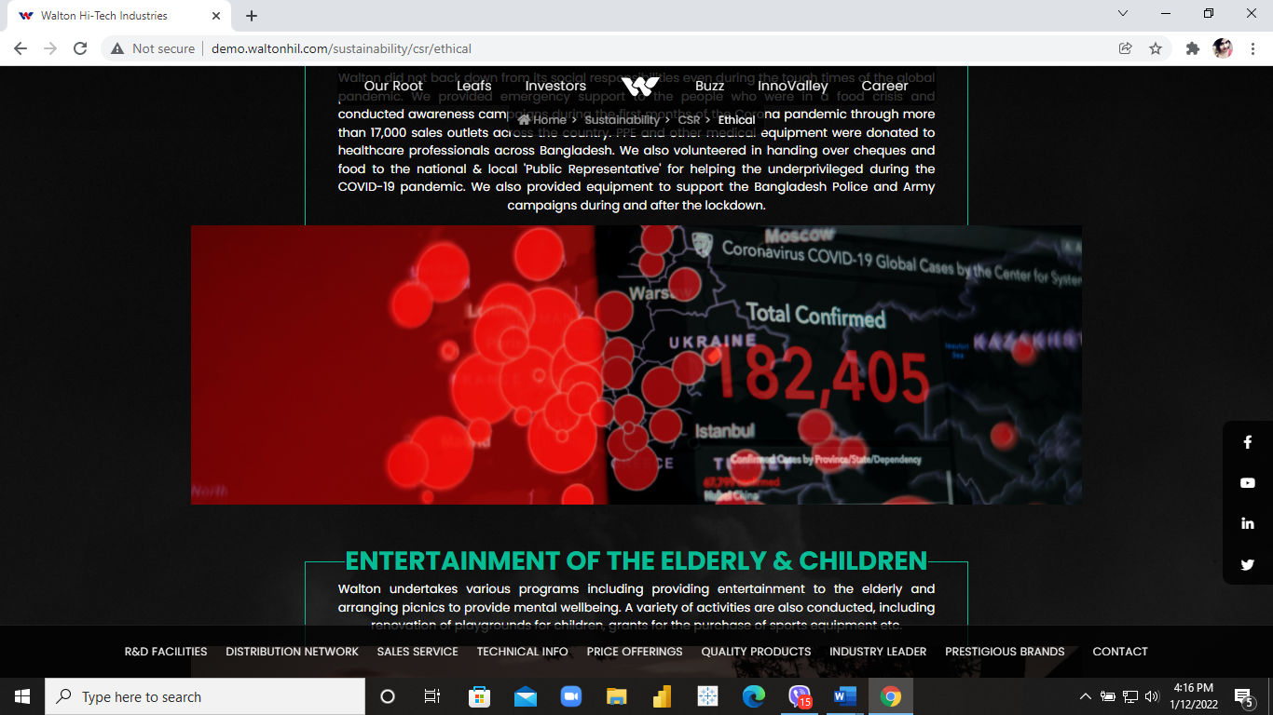

**Add sliders to accommodate 4 pictures.**

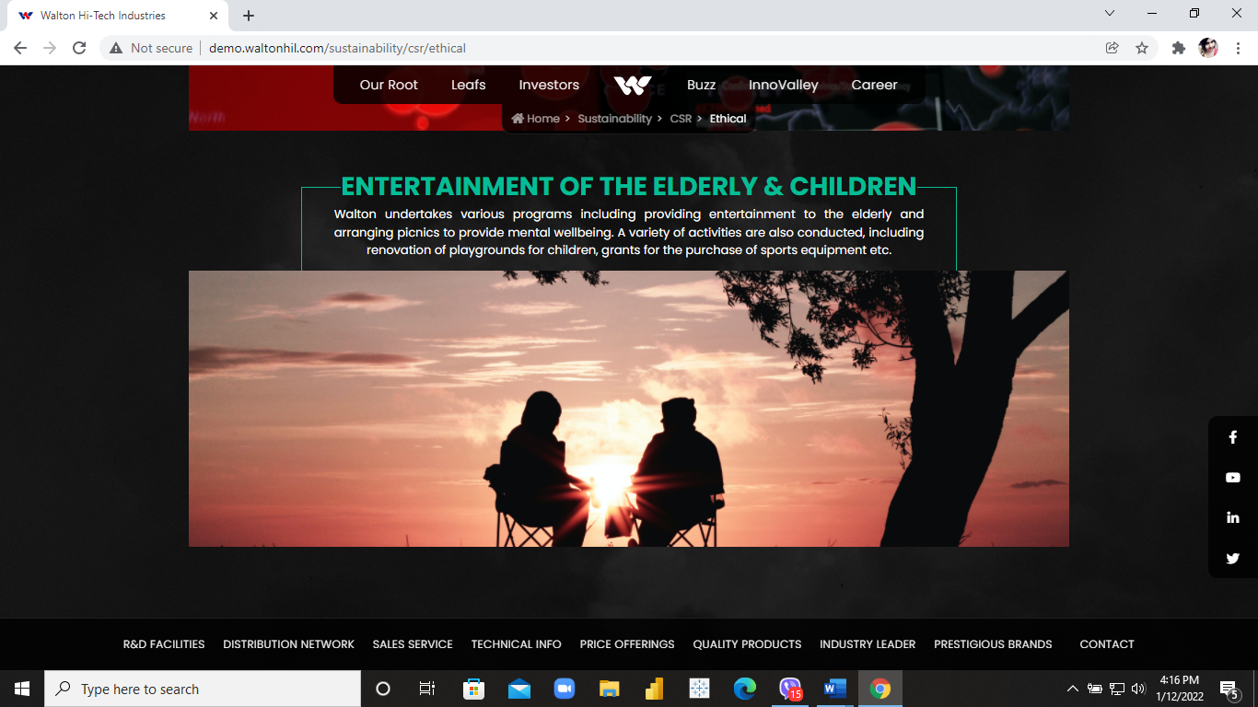

**Add sliders to accommodate 4 pictures.**

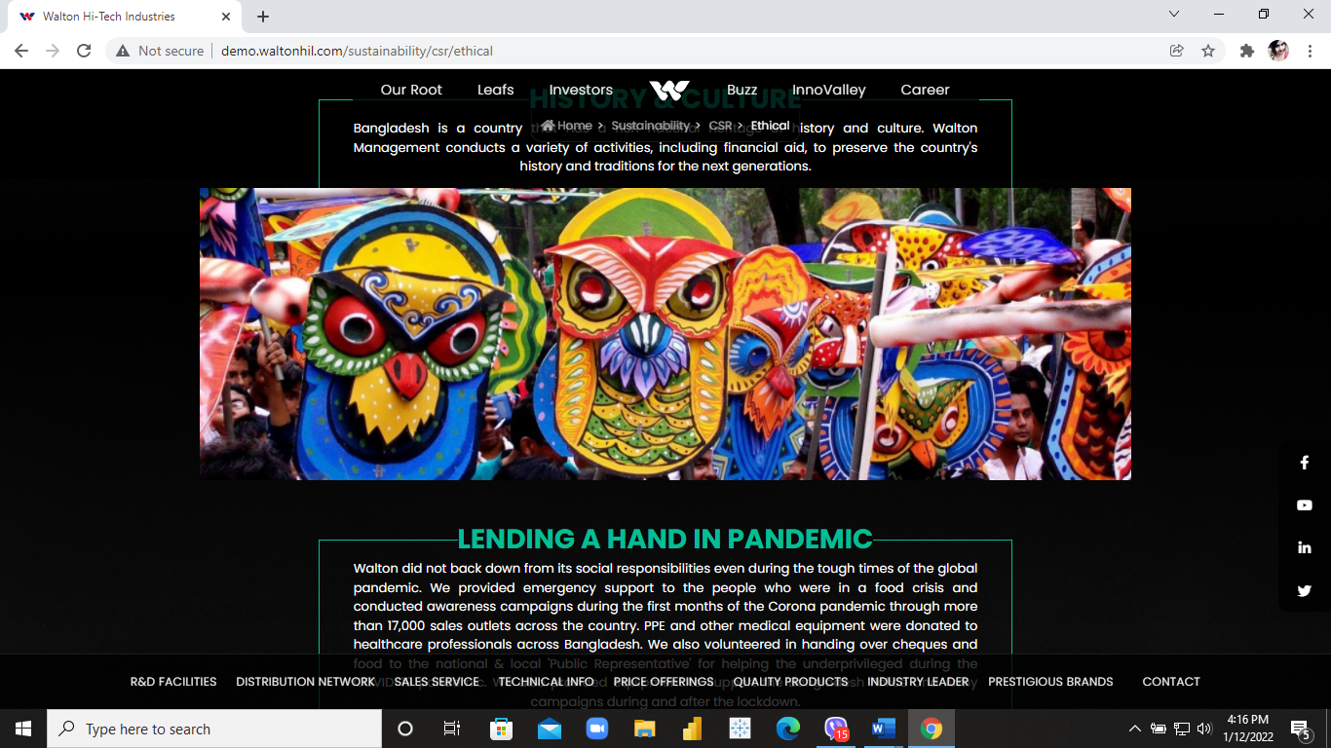

**Add sliders to accommodate 4 pictures.**

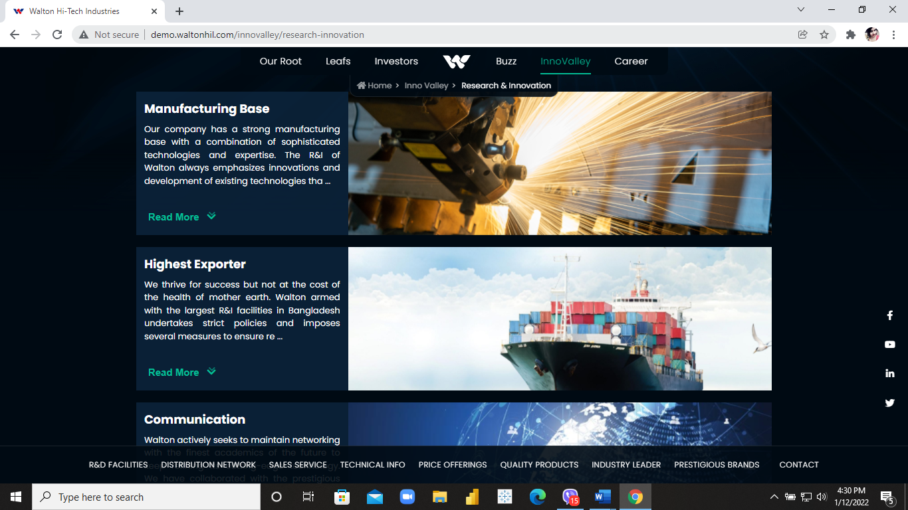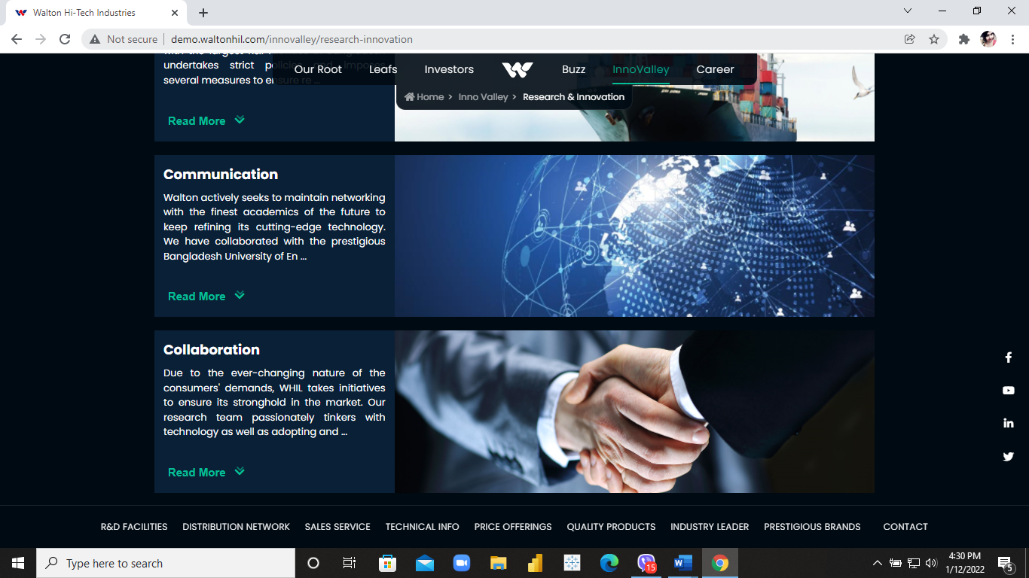

**Add sliders to accommodate 4 pictures**

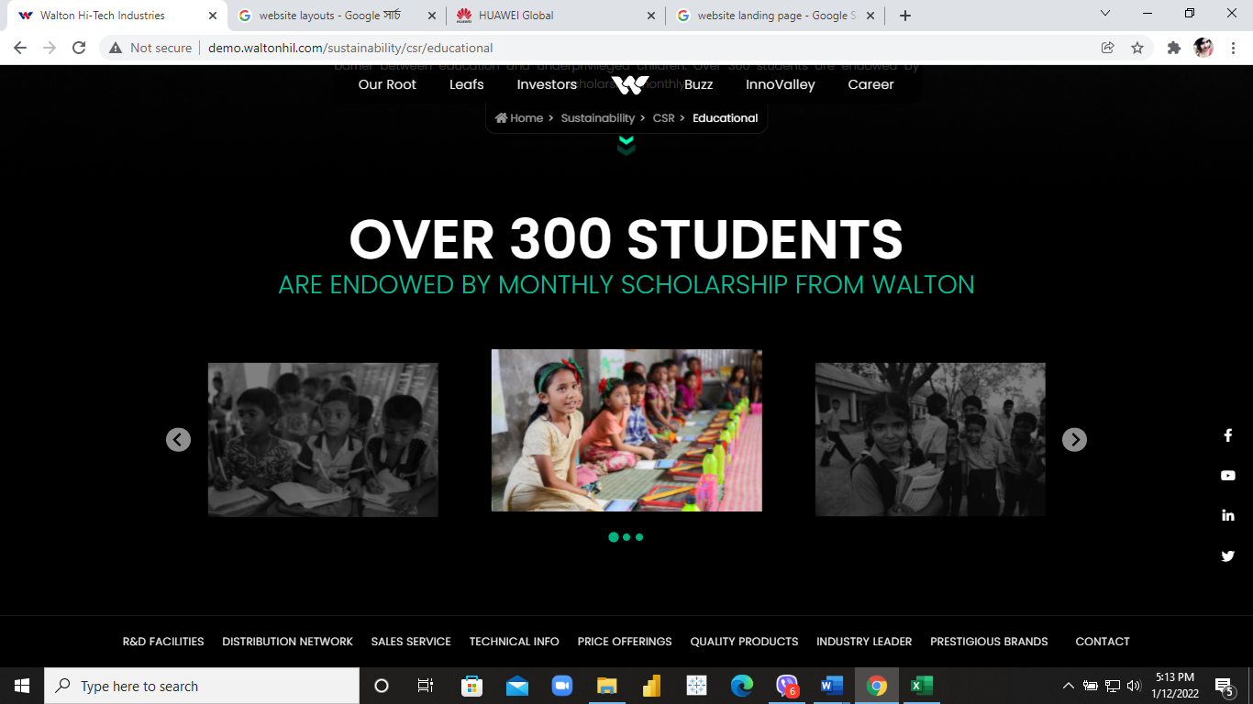

**SLIDERS SIMILAR TO THIS**

**Flagship Programs**

**Future Leaders’ Program**

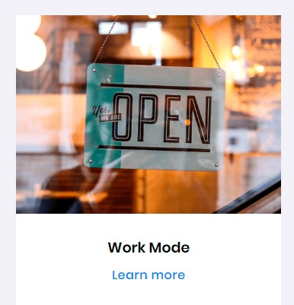 **LAYOUT**

More than 26000 CVs were sorted to find out the top 110 who battled initially in a scrutinized standardized written test held on May 18th, 2021.

WRITTEN TEST

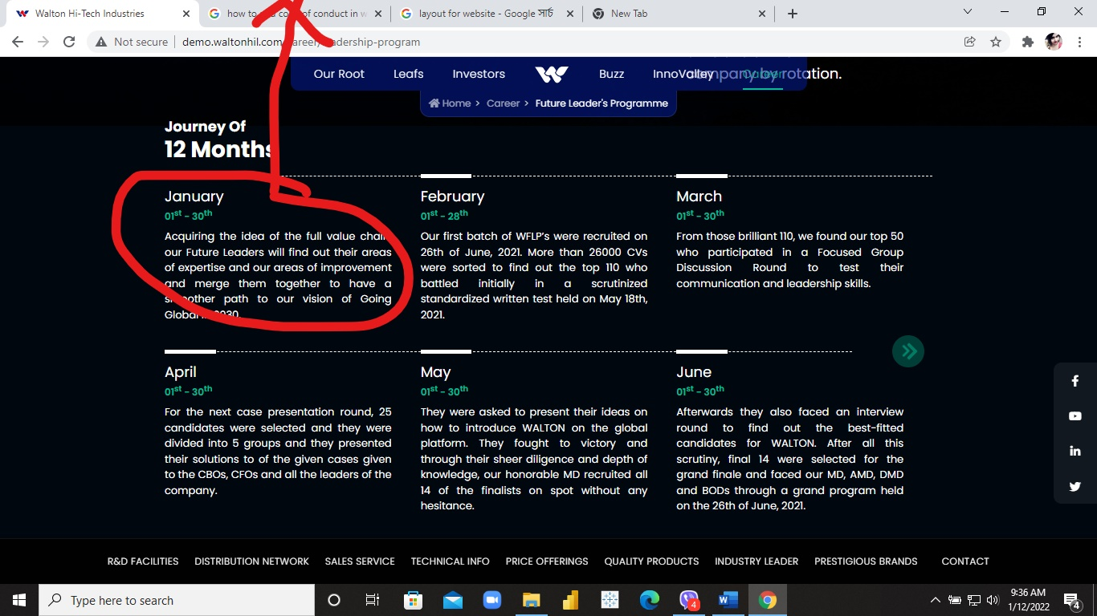

**Written Test:** More than 26000 CVs were sorted to find out the top 110 who battled initially in a scrutinized standardized written test held on May 18th, 2021. **With Image**

**Focused Group Discussion**: From those brilliant 110, we found our top 50 who participated in a Focused Group Discussion Round to test their communication and leaderships skills. **With Image**

**Case Presentation:** For the next case presentation round, 25 candidates were selected and they were divided into 5 groups and they presented their solutions to the cases given to the CBOs, CFOs and all the leaders of the company. **With Image**

**Interview:** Afterwards they also faced an interview round to find out the best-fitted candidates for WALTON. **With Image**

**Final Presentation:** After all this scrutiny, final 14 were selected for the grand finale and faced our MD, AMD, DMD and BODs through a grand program held on the 26th of June, 2021. They were asked to present their ideas on how to introduce WALTON on the global platform. **With Image**

**Victorious Fourteen:** They fought to victory and through their sheer diligence and depth of knowledge, our honorable MD recruited all 14 of the finalists on spot without any hesitance. He also mentioned seeing glimpses of himself among these bright minds which gave him confidence on their abilities. **With Image**

With this, the biggest program of Walton, WFLP came to an end and we found the leading faces of our future.

**FIGHT FOR VICTORY**

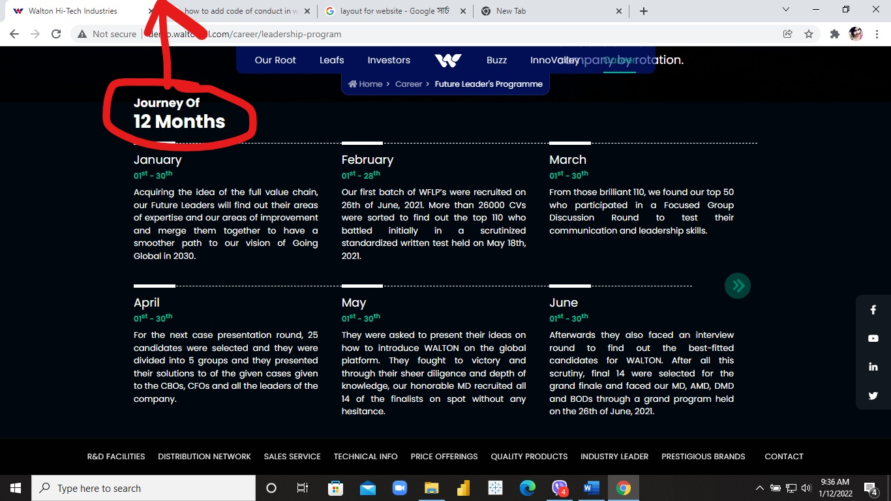

**Quality Maestros- Similar layout keep 6 slots**

**Thrive in Three- Similar layout keep 6 slots**

**Why WALTON**

**Are you looking for opportunities in the field of technology and plan to be part of the technological amelioration? Prove your mettle and integrate yourself into our conglomerate organization dedicated to bringing forth an illuminated and elegant future for the nation.**

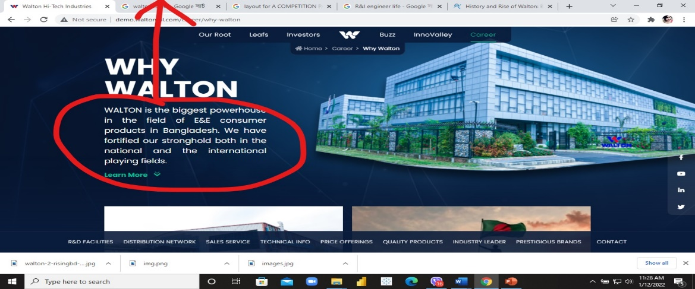

**Go Global**

**Where we are**

1. Nepal

Use this list to HIGHLIGHT countries on the world map

1. Sri Lanka
2. Hong Kong
3. Libya
4. Cyprus
5. Iraq
6. Poland
7. Uganda
8. Kenya
9. Tanzania
10. India
11. Australia
12. Spain
13. South Korea
14. Pakistan
15. Uk
16. Nigeria
17. Albania
18. Hongkong
19. UAE
20. China
21. Maldives
22. Timor Leste
23. Latvia.
24. Myanmar
25. Usa
26. Hungary
27. Denmark
28. Turkey
29. Romania
30. Lebanon
31. Malawi
32. Indonesia
33. Germany
34. Russia
35. Greece
36. Sarbia
37. Austria
38. Slovakia
39. Italy
40. Ireland
41. Croatia
42. Bhutan
43. Slovenia
44. Bulgaria

**Headquarters**

**Manufacturing**

**OUR PRODUCTION HEROS**

**OUR PRODUCTION HEROS**

**INTERVIEWS OF WORKERS**

**INTERVIEWS OF WORKERS (VIDEOS)**

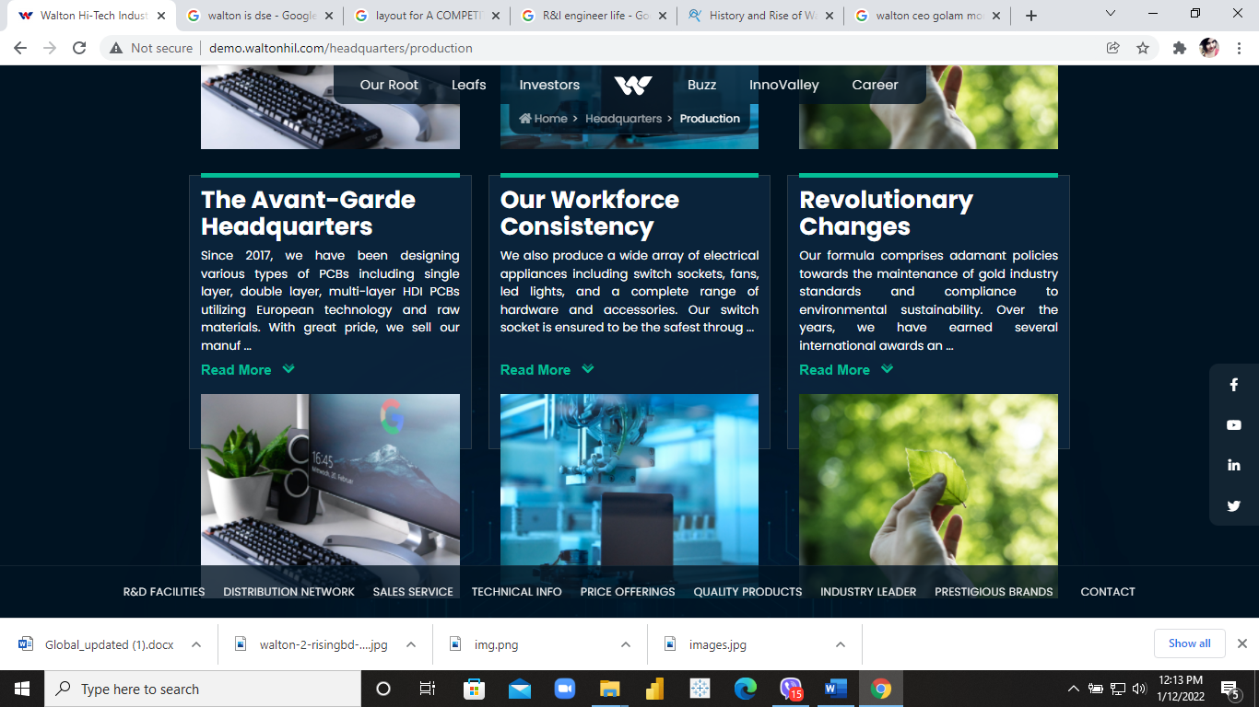

**LOGISTICS**

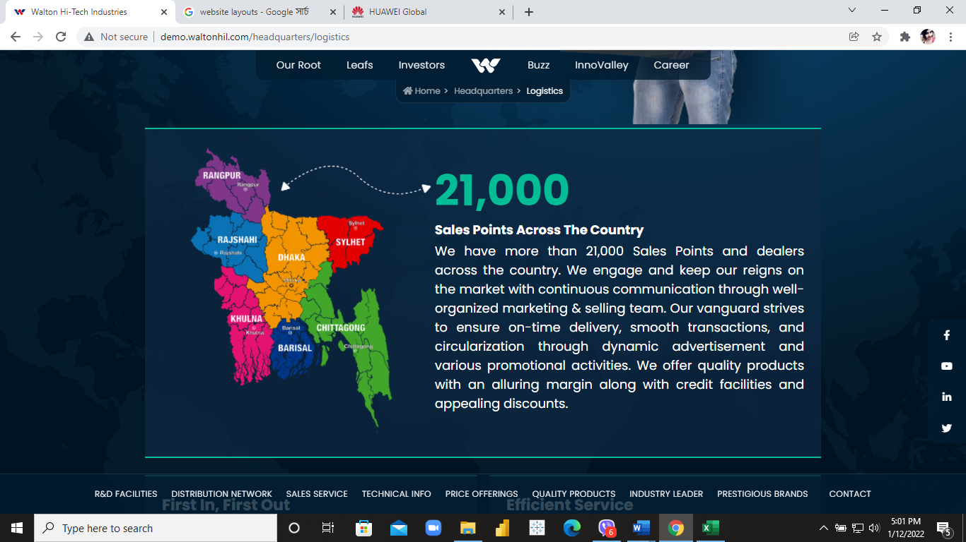

Interviews